MEGHNAD SAHA INSTITUTE OF TECHNOLOGY

*Techno Complex, Madurdaha,Beside NRI Complex, Post-Uchhepota, Kolkata 700 150*

LABORATORY NOTE BOOK

MAKAUT ODD SEMESTER 2024



[MASTERS OF COMPUTER APPLICATION]

[PROGRAMMING CONCEPT WITH PYTHON LAB (MCAN191)]

[RUPAK SARKAR]

ROLL NO: REGN. NO.:

STREAM: MCA SEMESTER: I (1ST)

YEAR: 1ST YearSESSION: 2024-2026



MAULANA ABUL KALAM AZAD UNIVERSITY OF TECHNOLOGY



MEGHNAD SAHA INSTITUTE OF TECHNOLOGY

*Techno Complex,. Madurdaha,Beside NRI Complex, Post-Uchhepota, Kolkata 700 150*

“LIST OF ASSIGNMENT/EXPERIMENT SUBMISSION DETAILS”

|  |  |  |  |  |  |
| --- | --- | --- | --- | --- | --- |
| **SL.**  **NO.** | **ASSIGNMENT / EXPERIMENT NAME** | **DATE OF EXPERIMENT** | **DATE OF SUBMISION** | **CHECKED BY** | **REMARKS (ANY DEVIATION REGARDING SUBMISSION DATES, CONTENT, FORMAT, ETC)** |
| 1. | WAP to calculate distance between two points | 22/11/2024 | 6/12/2024 |  |  |
| 2. | WAP to calculate area of triangle using Heron’s Formula | 22/11/2024 | 6/12/2024 |  |  |
| 3. | WAP to print ASCII value of a character. | 22/11/2024 | 6/12/2024 |  |  |
| 4. | WAP to take a string in upper case and print in lower case | 22/11/2024 | 6/12/2024 |  |  |
| 5. | WAP to find ab using for loop | 22/11/2024 | 6/12/2024 |  |  |
| 6. | WAP to print Leap Year. | 22/11/2024 | 6/12/2024 |  |  |
| 7. | WAP to print sum of digits. | 22/11/2024 | 6/12/2024 |  |  |
| 8. | WAP to find perfect number. | 22/11/2024 | 6/12/2024 |  |  |
| 9. | WAP to find even or odd number. | 22/11/2024 | 6/12/2024 |  |  |
|  |  |  |  |  |  |

|  |
| --- |
| OBSERVATIONS / COMMENTS ON THE OVERALL PERFORMANCE: |

Signature in full with date Signature in full with date

**Faculty / Technical Assistant Lab Examiner**

**Q.1. Write a program in python to calculate the distance between 2 points where x1,y1 and x2,y2:**

Ans:

import math

x1,y1= [int(c) for c in input("Enter the points to check: ").split()]

x2,y2= [int(c) for c in input("Enter the points to check: ").split()]

v=math.sqrt((x2-x1)**2 + (y2-y1)**2)

print("Distance:",v)

Output:

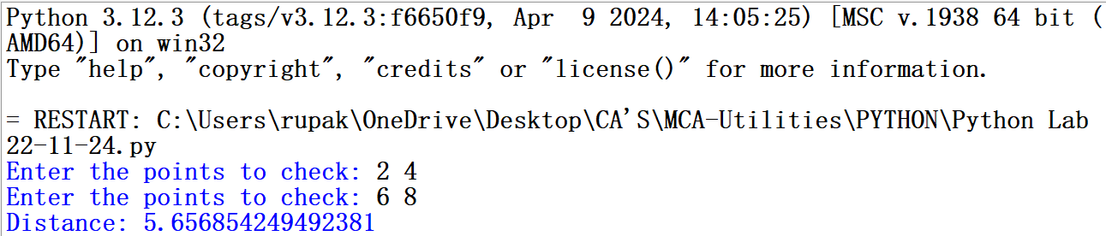

**Q.2. Write a python program to calculate area of a triangle using Heron’s f.**

Ans:

import math

a,b,c= [int(c) for c in input("Enter the points to check: ").split()]

s=a+b+c/2

area=math.sqrt(s*(s-a)*(s-b)*(s-c))

print("The area of the Triangle is: ",area)

Output:

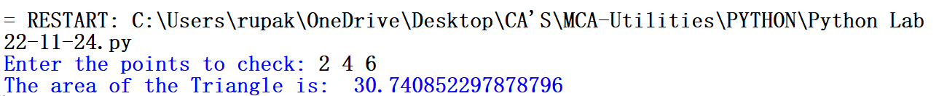

**Q.3. Write a program to print ASCII value of a character.**

Ans:

d=input("Enter the Character: ")

print("The ASCII value of",d," is: ", ord(d))

Output:

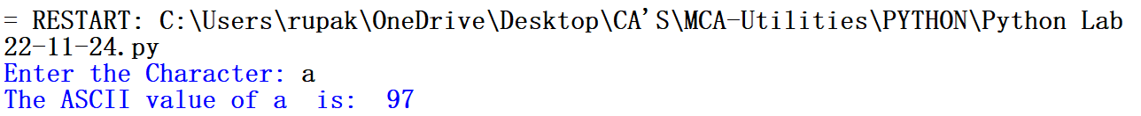

**Q.4. Write a python program to read a string in upper case and print it in lower case.**

Ans:

a=input("Enter the character: ")

print(a.upper())

print(a.lower())

Output:

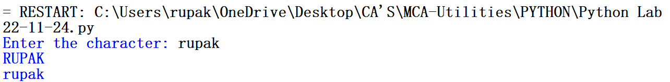

**Q.5. Write a python program to find ab using for loop.**

Ans:

a,b=[int(c) for c in input("Enter the numbers: ").split()]

p=1

for i in range(1,b+1):

p=p*a

print("Value of x^y is: ",p)

Output:



**Q.6. Write a python program to find whether a year is leap or not.**

Ans:

yr = int(input("Enter the year to check: "))

if (yr % 400 == 0) and (yr % 100 == 0):

print("%d is a leap year"%yr)

elif (yr % 4 ==0) and (yr % 100 != 0):

print("%d is a leap year"%yr)

else:

print("%d is not a leap year"%yr)

Output:



**Q.7. Write a python program to find the sum of digits of given number.**

Ans:

n=int(input("Enter the number to check: "))

s=0

while(n!=0):

r=n%10

s=s+r

n=n//10

print("Sum of the digits: ",s)

Output:



**Q.8. Write a python program to find Perfect Number.**

Ans:

n=int(input("Enter the number: "))

s=0

for i in range(1,(n-1)):

if(n%i==0):

s=s+i

if(s==n):

print("%d is a Perfect Number."%s)

else:

print("%d is not a Perfect Number."%s)

Output:



**Q.9. Write a python program to find whether a number is Even or Odd.**

Ans:

a=int(input("Enter the number to check: "))

if(a%2==0):

print("%d is an Even Number."%a)

else:

print("%d is a Odd Number."%a)

Output:

